S2. PRISMA flowchart
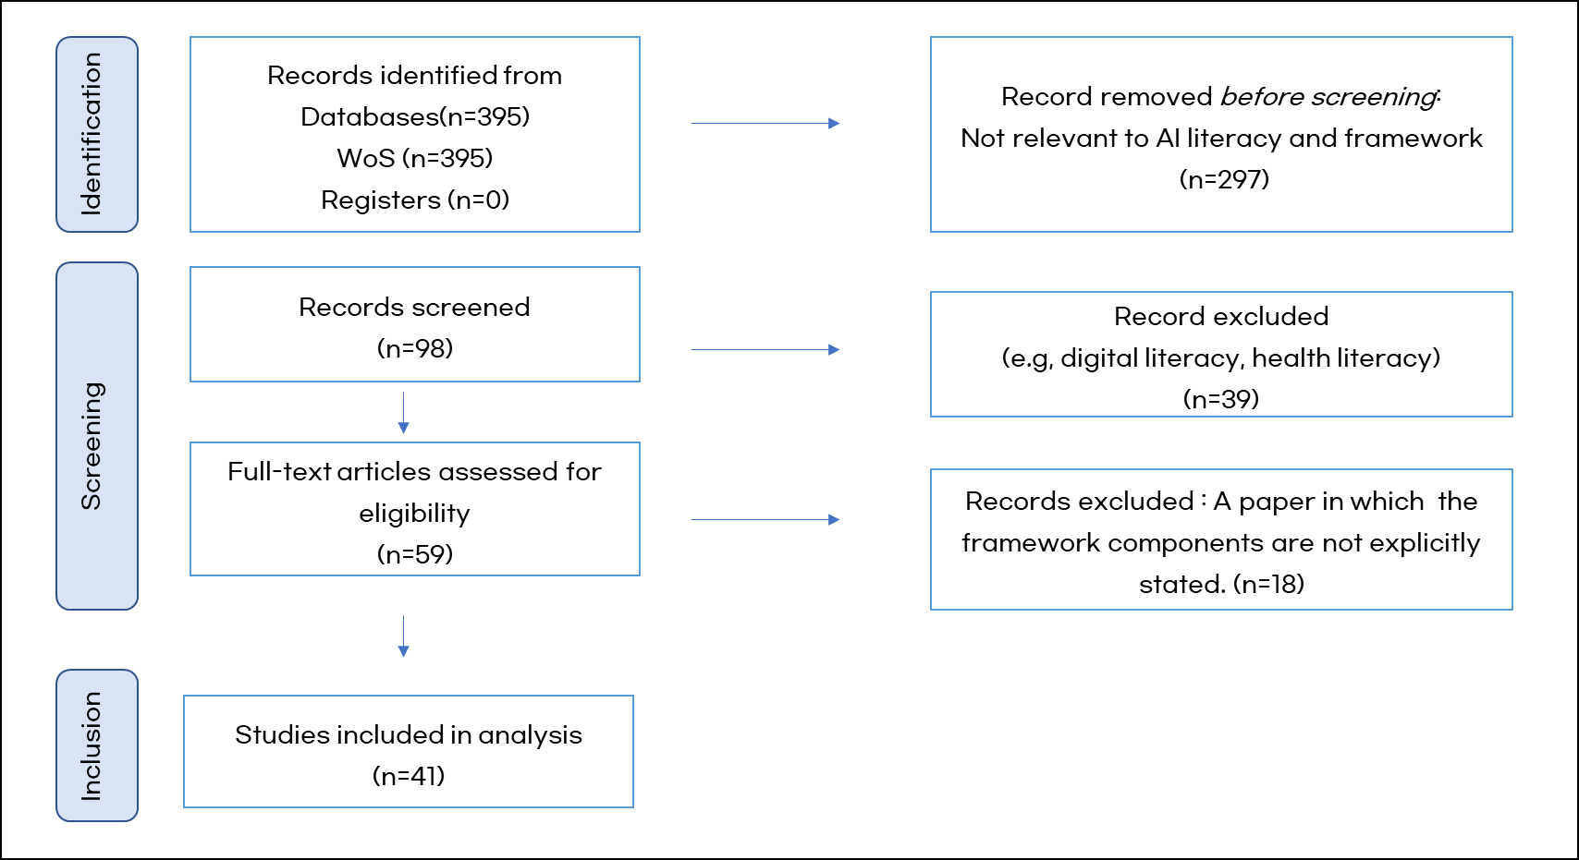
Figure 1 PRISMA flowchart

